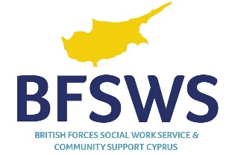
TRAINING REQUEST FORM
Please complete this form and email to safeguardingcyprus@forcessocialwork.com
If you would like to discuss your training request, please contact us on 2596 3609

Safeguarding Training | Note which Safeguarding course is required
Date and venue
Employee name |  | Email:
Department |  | Phone ext.

Please answer the questions below as fully as possible
Has this training been identified through your employee review discussion?
What is the priority for this training?
What are the development needs you wish to address by attending this training?
What is your aims and objectives of the training?
How will this training support delivery of departmental and personal objectives?
How will you apply the learning to your practice?
If applicable, please agree with your line manager how you will share what you have learned.

Do you have any special requirements that we need to be aware of?  If yes, please provide details below: |  | Yes or No
Manager
This section to be completed by the line manager
How will this training support delivery of strategic or departmental objectives?
Employee | Line Manager
Name: | Name:
Signature: | Signature:
Date: | Date:
Please complete this form and email to safeguardingcyprus@forcessocialwork.com

IMPORTANT
Cancellation
If, for any reason, you are unable to attend the course, please contact us as soon as possible. If you have any queries prior to the training, please do not hesitate to contact any of the team:

Email - safeguardingcyprus@forcessocialwork.com

Telephone – (00 357) 2596 2258

